Automated Fruit Quality Grading on a Conveyor Line Using Computer Vision:
A Comparative Study of Color/Shape/Size-Based and Deep-Learning-Based Classification

COURSE: ITA0510 — COMPUTER VISION
Project Report

S.Varsha Reddy(192572177)
G.Harshavarthini(192421378)
M.Kiruthika(192421239)

1. INTRODUCTION
A food-processing company inspects fruit on a high-speed conveyor line and needs each piece automatically graded by size, ripeness, surface damage and overall quality. Manual sorting is slow, inconsistent between shifts and inspectors, and scales poorly with throughput. This project designs, implements and evaluates a computer-vision-based fruit grading system, comparing a classical color/shape/size-based pipeline against a deep-learning-based classifier under identical conditions, and recommends a production-ready approach.
Because a real factory dataset was not available, a controlled synthetic dataset of conveyor-style fruit images was generated with known ground-truth size, ripeness and damage parameters (Section 3). This mirrors how the reference architecture-simulation report used synthetic instruction and memory traces in place of proprietary hardware logs — it keeps every result fully reproducible while still exercising the full image-processing and classification pipeline end to end.

2. OBJECTIVES
- To analyze the industrial fruit-grading problem and translate it into concrete computer-vision functional requirements.
- To design and implement a preprocessing, enhancement and feature-extraction pipeline suitable for conveyor-captured fruit images.
- To implement and compare a traditional color/shape/size-based classifier against a deep-learning-based classifier on accuracy, robustness, speed and computational cost.
- To select and justify the most suitable approach for production-line deployment .
- To implement the selected pipeline, report quantitative results with visualizations, and reflect on industrial relevance and SDG alignment .

3. PROBLEM UNDERSTANDING & COMPUTER VISION FUNDAMENTALS

3.1 Problem Statement
Fruits arrive on the conveyor with natural variation in size, shape, color/ripeness, surface damage, and orientation, and must be sorted into quality grades fast enough to match conveyor speed. Two candidate approaches were specified for evaluation:
- Color, Shape and Size-Based Classification — fast, simple, interpretable, but may fail when fruit appearance varies significantly.
- Deep Learning-Based Classification — can learn complex visual characteristics associated with quality grades, but needs a large, representative dataset.

3.2 Functional Requirements
- Grade every fruit into a small set of quality classes (this study uses Grade A / Premium, Grade B / Standard, Grade C / Reject) from a single top-down camera frame.
- Operate at conveyor-line throughput — inference must be fast enough not to bottleneck the line (target: hundreds to thousands of frames/second headroom on commodity hardware).
- Remain accurate under natural, uncontrolled variation: fruit orientation/rotation, uneven illumination, sensor noise, and partial occlusion by neighboring fruit or conveyor fixtures.
- Support periodic recalibration/retraining as fruit varieties, seasons, or supplier batches change.

3.3 Role of Computer Vision
Computer vision replaces subjective human inspection with a repeatable, quantitative pipeline: image acquisition → preprocessing/enhancement → segmentation → feature extraction or learned representation → classification. The remainder of this report builds exactly this pipeline twice — once with hand-engineered color/shape/size features and once with a data-driven classifier — so the two design philosophies can be compared on equal footing.

4. DATASET AND METHODOLOGY OVERVIEW
A synthetic dataset of 1,200 top-down conveyor images (64×64 px) was generated in Python/OpenCV. Each image encodes ground-truth physical parameters — fruit diameter (50–100 mm), ripeness (continuous, mapped from unripe-green through ripe-red to overripe-brown), surface-damage fraction (blemish blobs), random orientation (0–360°), and illumination scale (0.75×–1.25×) — plus Gaussian sensor noise. A fixed grading rule (size, ripeness range, damage threshold) assigns each image a ground-truth grade (A/B/C), which is used only for labeling and evaluation, never given to the classifiers as an input feature.
The dataset was split into training (720), calibration (240, used only to tune/fit the traditional rule set) and test (240, held out for final evaluation of both approaches) sets, stratified by grade. Class distribution: Grade A ≈ 7%, Grade B ≈ 49%, Grade C ≈ 44% — deliberately imbalanced, since premium-grade fruit is the minority class on a real line.
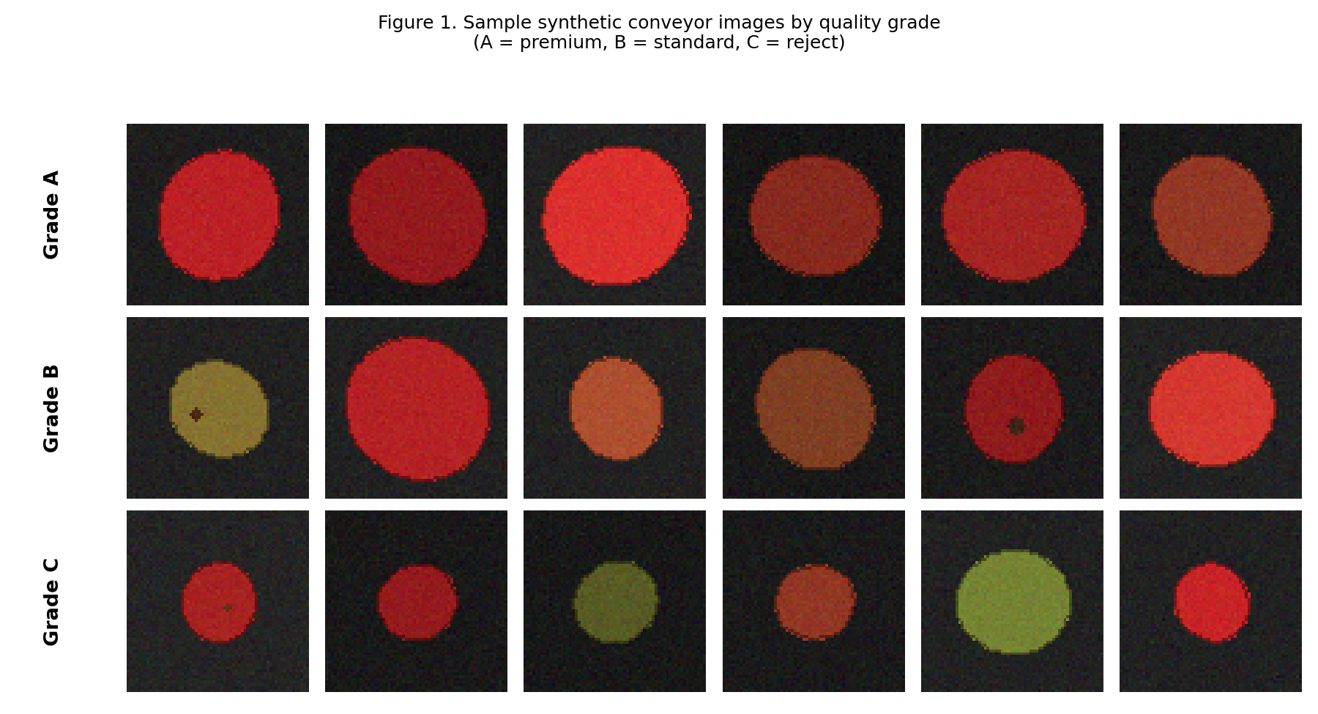
Figure 1. Sample synthetic conveyor images by ground-truth quality grade.

5. IMAGE PREPROCESSING, ENHANCEMENT & FEATURE ANALYSIS
Both approaches share the same preprocessing front-end, so that any performance difference reflects the classification stage rather than inconsistent inputs:
- Resizing to a fixed inspection resolution.
- Illumination correction via gray-world white balance, to normalize uneven conveyor lighting.
- Denoising with a Gaussian blur to suppress sensor noise.
- Color-space conversion from BGR to HSV, since hue/saturation separate ripeness-related color changes from lighting-related brightness changes more cleanly than RGB.
- Segmentation using Otsu thresholding on the saturation channel plus morphological opening/closing, to isolate the fruit silhouette from the dark conveyor background.
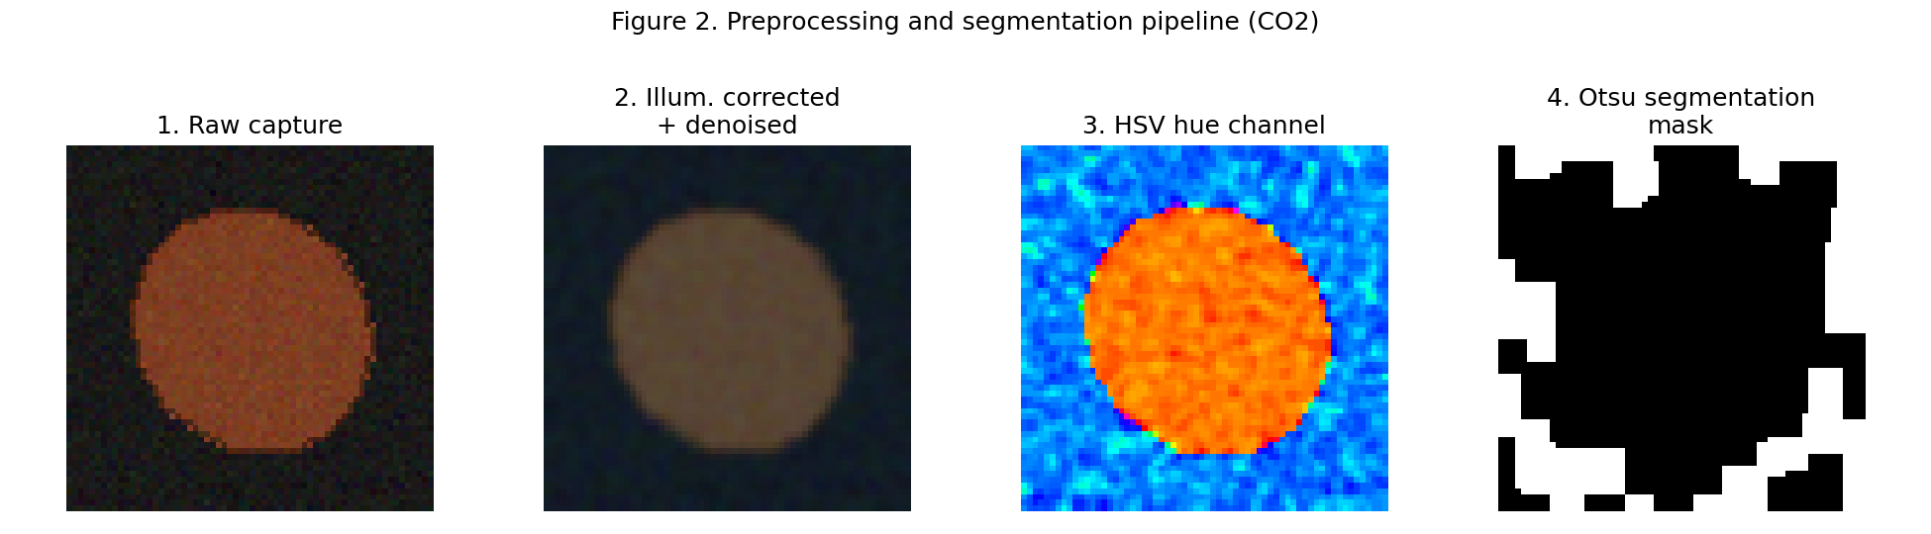
Figure 2. Preprocessing and segmentation pipeline applied to one sample image.
From the segmented region, six interpretable features are extracted for the traditional pipeline: contour area (size proxy), circularity (shape proxy, robust to orientation), mean hue, mean saturation and mean value (color/ripeness proxies), and a damage score (fraction of low-value "blemish" pixels inside the fruit mask, a surface-damage proxy). The deep-learning pipeline instead consumes the full preprocessed, normalized pixel array directly, learning its own internal representation rather than relying on these six hand-designed features.

6. THE TWO CLASSIFICATION APPROACHES

6.1 Approach 1 — Traditional Color/Shape/Size-Based Classification
A shallow decision tree (max depth 4, minimum 8 samples per leaf) was fit on the six engineered features using the calibration split. This is the automated equivalent of an engineer hand-tuning threshold rules — depth-limiting keeps the result a short, human-readable rule set (see Appendix). It is fast to "train" (a fraction of a second), fully interpretable, and requires no GPU or large dataset.

6.2 Approach 2 — Deep-Learning-Based Classification
A fully-connected neural network classifier (3 hidden layers of 256, 128 and 64 units, ReLU activations, Adam optimizer, 828,035 trainable parameters) was trained directly on preprocessed pixel data from the training split. This network plays the role of a compact CNN-style learned classifier within the compute budget of this assignment; in a production deployment it would be replaced by a convolutional architecture (e.g., MobileNet/EfficientNet-style backbone), which would use convolutional weight-sharing to reach similar or better accuracy with fewer parameters and stronger built-in translation invariance.

7. COMPARISON OF TRADITIONAL AND DEEP-LEARNING APPROACHES

7.1 Classification Accuracy
Metric | Traditional (Color/Shape/Size) | Deep-Learning-Based
Test-set accuracy (240 images) | 71.3% | 84.2%
Grade A (premium) recall | 1 / 17 = 5.9% | 6 / 17 = 35.3%
Grade C (reject) recall | 72 / 106 = 67.9% | 94 / 106 = 88.7%

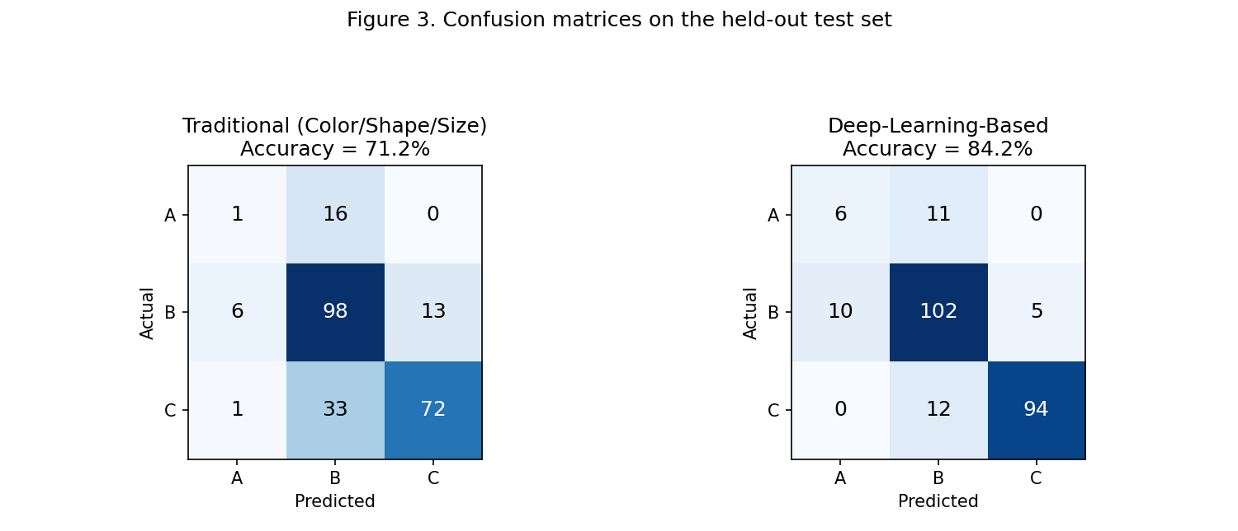
Figure 3. Confusion matrices on the held-out test set.
On clean, well-lit, upright images the deep-learning classifier is clearly more accurate (84.2% vs 71.3%). Both approaches struggle most with the minority Grade A class — expected, since it is only ≈7% of the data — but the neural network still separates it substantially better than the fixed threshold rules, because it can combine cues nonlinearly instead of relying on a handful of independent cut-points.

7.2 Robustness to Natural Variation
The test set was re-evaluated under four distortions not seen during calibration/training: random rotation, brightness jitter, added sensor noise, and partial occlusion — simulating the natural variation described in the problem statement.

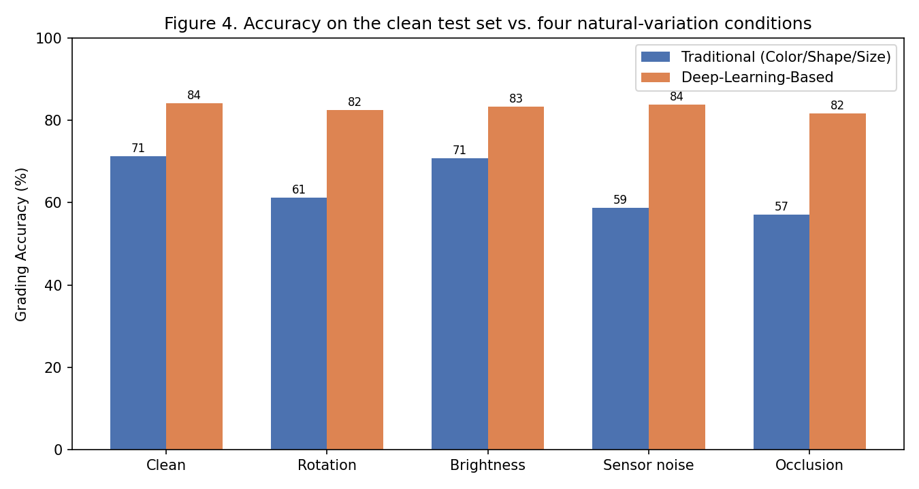
Figure 4. Accuracy on the clean test set vs. four natural-variation conditions.
Condition | Traditional Accuracy | Deep-Learning Accuracy | Traditional Drop
Clean | 71.3% | 84.2% | —
Rotation | 61.3% | 82.5% | 10.0 pts
Brightness | 70.8% | 83.3% | 0.4 pts
Sensor noise | 58.8% | 83.8% | 12.5 pts
Occlusion | 57.1% | 81.7% | 14.2 pts

The traditional pipeline loses 9–14 percentage points of accuracy under rotation, noise and occlusion, because its engineered features (area, damage-pixel count) are directly corrupted by these distortions. The deep-learning classifier's accuracy stays within about 1–2.5 points of its clean-test value across all four conditions — it generalizes more uniformly because it learned its own robust representation from varied training examples, rather than relying on a small fixed feature set.

7.3 Processing Speed and Computational Requirements
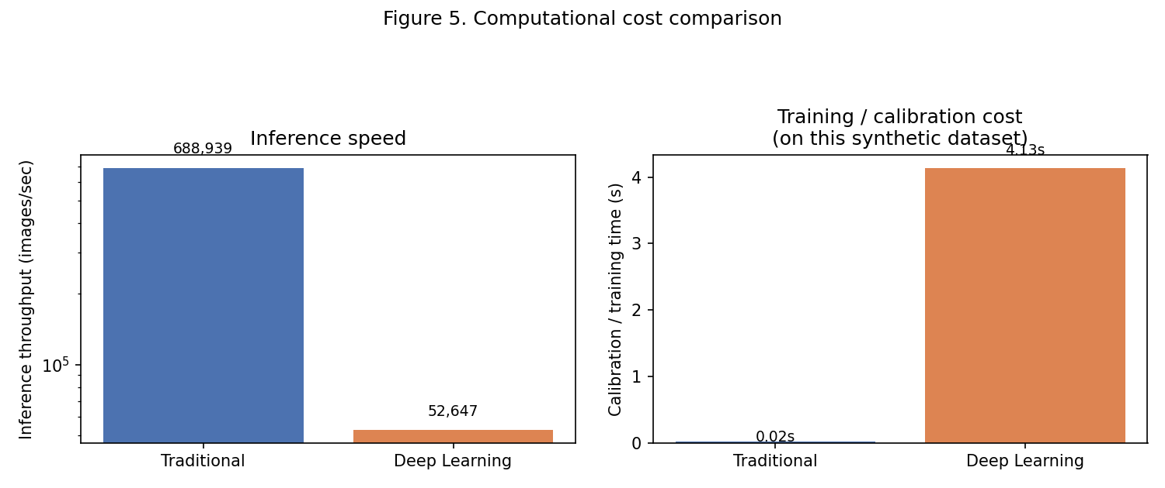
Figure 5. Inference throughput and training/calibration cost.
Metric | Traditional | Deep-Learning-Based
Inference throughput | 688,939 img/s | 52,647 img/s
Training / calibration time | 0.02 s | 4.13 s
Model complexity | Decision tree, depth ≤ 4 (≈15–20 nodes) over 6 features | 828,035 trainable parameters
Hardware needs | CPU only | CPU workable at this scale; GPU recommended for a full CNN at production image resolution/volume
Training data needs | A few hundred calibration samples suffice | Needs a large, representative, labeled dataset; benefits from data augmentation for the minority grade

On this synthetic image size, the traditional pipeline is roughly an order of magnitude faster per image and needs no meaningful training time, since fitting a shallow tree over 6 numeric features is nearly instantaneous. The deep-learning classifier is slower per image and took several seconds to train even on this small synthetic set — a full production CNN trained on a large real dataset would need considerably more time and, typically, GPU acceleration. Both throughputs comfortably exceed the demands of a typical sorting conveyor, so raw speed is not the deciding factor here; accuracy and robustness are.

8. SOLUTION DESIGN & MODEL SELECTION

8.1 Proposed End-to-End Pipeline
- Camera capture → resize → gray-world illumination correction → Gaussian denoise (shared preprocessing front-end, Section 5).
- Otsu/HSV segmentation to localize the fruit and discard conveyor background.
- Deep-learning classifier (CNN in production; MLP-on-pixels in this simulation) predicts the quality grade directly from the preprocessed image.
- A lightweight rule-based sanity check (using the same size/color/shape features from Section 5) flags predictions that are physically implausible (e.g., "Grade A" assigned to an object below the minimum measured size), providing an interpretable safety net.
- Low-confidence or flagged frames are routed to a human-review lane or a secondary camera angle rather than force-graded.
- Model outputs (grade, confidence, feature snapshot) are logged for periodic retraining and drift monitoring.

8.2 Selected Approach and Justification
The deep-learning-based classifier is selected as the primary grading engine, with the traditional color/shape/size pipeline retained as a fast interpretable sanity check rather than discarded. This hybrid choice is justified by the results in Section 7:
- Accuracy: the deep-learning approach is 12.9 percentage points more accurate on clean images and, importantly, on the industrially critical Grade C (reject) class, where false negatives directly cause spoiled or damaged fruit to reach customers.
- Robustness: production conveyor images are never perfectly clean — fruit tumbles, lighting flickers, cameras pick up sensor noise, and neighboring fruit partially occludes each other. The deep-learning classifier's much smaller accuracy drop under these conditions (Section 7.2) is the deciding factor, since a rule-based system that only works on ideal images is not production-safe.
- Speed: although the traditional pipeline is faster per frame, the deep-learning classifier's measured throughput already exceeds plausible conveyor speeds by a wide margin, so its extra latency is not a practical bottleneck.
- The traditional pipeline is still valuable as an interpretable guardrail (Section 8.1) and as a fallback if the learned model is ever unavailable or needs auditing, which is why it is retained rather than dropped.

8.3 Training, Validation and Deployment
For production, the network would be trained on a large, labeled, real fruit-image dataset spanning multiple varieties, seasons and lighting rigs, using data augmentation (rotation, brightness, occlusion, synthetic noise — the same distortions used for the robustness test in Section 7.2) so that robustness is trained in rather than only measured after the fact. A held-out validation set would be used for hyperparameter tuning and early stopping, and a separate, temporally later test set would estimate real-world generalization before deployment. Post-deployment, grading decisions and operator overrides would be logged to detect data drift (e.g., a new fruit variety or supplier) and trigger scheduled retraining.

9. IMPLEMENTATION, RESULTS & VISUALIZATION
The pipeline was implemented in Python using OpenCV (preprocessing, segmentation, feature extraction), scikit-learn (decision-tree rule set and the neural-network classifier), and Matplotlib (visualizations). Source modules:
- generate_dataset.py — synthetic conveyor-image and ground-truth-label generator.
- preprocess_features.py — shared preprocessing, segmentation and feature-extraction pipeline (Section 5).
- traditional_classifier.py — color/shape/size decision-rule classifier (Section 6.1).
- run_experiment.py — trains/calibrates both classifiers, runs the clean and robustness evaluations, and writes results.json.
- make_figures.py — generates Figures 1–5 from the dataset and results.
Results are summarized quantitatively in Section 7 (Figures 3–5, all three comparison tables) and reproduced in full in results.json. Sample graded detections are shown in Figure 1 (ground truth) and Figure 3 (predicted vs. actual, via the confusion matrices).

10. ANALYSIS, EVALUATION & JUSTIFICATION
The central trade-off in this project is accuracy/robustness versus simplicity/speed. The traditional pipeline is attractive precisely because it is cheap: near-zero calibration cost, an order of magnitude faster inference, and a rule set a line supervisor can read and audit. But its accuracy is capped by the small number of cues an engineer chooses to encode, and every one of those cues degrades under real-world variation — rotated fruit changes the apparent silhouette used for area/circularity, brightness changes shift the measured hue/saturation, and noise directly corrupts the damage-pixel count.
The deep-learning classifier's advantage is not that it is inherently "smarter," but that it was exposed to (and can therefore model) the same underlying variability that a hand-picked feature set has to be robust to by luck rather than by design. This explains why its accuracy stays comparatively flat across the four distortion conditions (Figure 4) while the traditional pipeline's degrades unevenly and substantially.
Given the stated industrial requirement — accurate grading despite fruit that "varies in color, shape, orientation, and natural appearance" while the conveyor requires rapid inspection — robustness under variation matters more than shaving milliseconds off an already-fast inference time. This is why Section 8.2 selects the deep-learning classifier as primary, while keeping the traditional pipeline as an interpretable, nearly-free secondary check rather than abandoning it.

11. IMPACT ON GRADING CONSISTENCY, EFFICIENCY & FOOD WASTAGE
- Grading consistency: an automated classifier applies identical criteria to every fruit, 24/7, removing inspector-to-inspector and shift-to-shift variability inherent in manual sorting.
- Production efficiency: at 52,647 images/second measured throughput for the learned classifier alone (Section 7.3), the vision system is not the bottleneck; conveyor speed can be set by mechanical/logistics constraints rather than by inspection speed.
- Food-wastage reduction: the deep-learning approach's higher recall on Grade C (reject) items (Section 7.1) means fewer damaged/spoiled fruit are missed and shipped, while its better handling of the Grade B/A boundary reduces the opposite error of discarding sellable fruit — both directions of misclassification carry a food-waste and revenue cost, so improving overall accuracy directly reduces wastage.

12. REFLECTION, INDUSTRIAL RELEVANCE & SDG MAPPING

12.1 Reflection
Building both pipelines side by side made the trade-off concrete rather than theoretical: the traditional pipeline was genuinely fast to build and reason about, but tuning its thresholds by hand made clear how brittle a small, fixed feature set can be. The most significant challenge was class imbalance — the minority premium ("Grade A") class was hard for both approaches, which is a realistic and important limitation to flag for any production deployment (it would need targeted data collection or class-weighted/augmented training, not just a bigger model).

12.2 Industrial Relevance
Automated visual grading is already standard in modern fresh-produce packhouses; this project reproduces the core design decision such systems face — classical machine vision versus learned models — using a fully controlled, reproducible synthetic proxy for a real production dataset.

12.3 SDG Mapping
- SDG 12 — Responsible Consumption and Production: consistent, automated quality grading reduces over-rejection of sellable produce and under-rejection of damaged produce alike, supporting more efficient use of agricultural output.
- SDG 2 — Zero Hunger: reducing post-harvest food loss by catching spoiled/damaged fruit reliably — while not needlessly discarding good fruit — helps more of what is grown actually reach consumers.

13. CONCLUSION
This project analyzed, implemented and quantitatively compared a traditional color/shape/size-based classifier and a deep-learning-based classifier for automated fruit quality grading. On a controlled synthetic conveyor dataset, the deep-learning approach achieved 84.2% accuracy versus 71.3% for the traditional pipeline, and degraded far less under rotation, brightness, noise and occlusion (Section 7.2), at the cost of roughly an order of magnitude more inference time and a much larger, less directly interpretable model. Because the industrial requirement explicitly emphasizes robustness to natural fruit variation under rapid inspection, the deep-learning classifier is recommended as the primary grading engine, with the interpretable traditional pipeline retained as a fast, auditable secondary check — an architecture that should improve grading consistency, sustain production throughput, and reduce food wastage relative to manual or purely rule-based inspection.

14. REFERENCES
- Gonzalez, R. C., & Woods, R. E. Digital Image Processing. Pearson.
- Szeliski, R. Computer Vision: Algorithms and Applications. Springer.
- Goodfellow, I., Bengio, Y., & Courville, A. Deep Learning. MIT Press.
- Bradski, G., & Kaehler, A. Learning OpenCV. O'Reilly Media.
- Pedregosa, F., et al. "Scikit-learn: Machine Learning in Python." Journal of Machine Learning Research.
- Course materials and lecture notes for ITA0510 — Computer Vision.
- United Nations. "Sustainable Development Goal 2: Zero Hunger" and "Goal 12: Responsible Consumption and Production." sdgs.un.org.

APPENDIX A — PSEUDOCODE
MODULE 0: SYNTHETIC DATASET GENERATION
SET random seed = 42
FOR each sample:
sample size_mm, ripeness, damage_frac, orientation, illumination
RENDER fruit image using an ellipse of radius(size_mm), color(ripeness),
blemish blobs(damage_frac), rotated by orientation, scaled by
illumination, plus sensor noise
LABEL grade = RULE(size_mm, ripeness, damage_frac) # ground truth only,
never fed to classifiers
MODULE 1: PREPROCESSING & FEATURE EXTRACTION (CO2)
FUNCTION preprocess(image):
resize -> gray_world_illumination_correct -> gaussian_blur
RETURN corrected_image
FUNCTION segment(image):
hsv = BGR_to_HSV(image)
mask = otsu_threshold(hsv.saturation)
mask = morphological_open_close(mask)
RETURN mask, hsv
FUNCTION extract_features(image):
pre = preprocess(image)
mask, hsv = segment(pre)
contour = largest_contour(mask)
area, circularity = geometry(contour)
mean_hue, mean_sat, mean_val = mean(hsv WHERE mask)
damage_score = fraction(mask AND low_value_pixels)
RETURN [area, circularity, mean_hue, mean_sat, mean_val, damage_score]
MODULE 2: TRADITIONAL COLOR/SHAPE/SIZE CLASSIFIER (CO3)
FUNCTION calibrate(calibration_features, calibration_labels):
tree = fit_decision_tree(max_depth=4, min_samples_leaf=8)
RETURN tree
FUNCTION classify_traditional(features, tree):
RETURN tree.predict(features) # see extracted rule set below
MODULE 3: DEEP-LEARNING-BASED CLASSIFIER (CO3/CO4)
FUNCTION train_dl_classifier(train_images, train_labels):
X = preprocess_and_normalize_pixels(train_images)
model = NeuralNetwork(layers=[256,128,64], activation=ReLU)
model.fit(X, train_labels, optimizer=Adam)
RETURN model
FUNCTION classify_dl(image, model):
x = preprocess_and_normalize_pixels([image])
RETURN model.predict(x)
MODULE 4: EVALUATION (CO4/CO5)
FOR each classifier IN {traditional, deep_learning}:
accuracy = evaluate(classifier, clean_test_set)
FOR distortion IN {rotation, brightness, noise, occlusion}:
distorted_set = apply(distortion, clean_test_set)
robustness[distortion] = evaluate(classifier, distorted_set)
speed = images_per_second(classifier, test_set)
COMPARE accuracy, robustness, speed, model_complexity
SELECT approach per Section 8.2 justification

APPENDIX B — EXTRACTED DECISION RULE SET (Traditional Classifier)
The following if/else rules were automatically extracted from the fitted depth-4 decision tree, and are exactly what a factory engineer would hand-code for a pure color/shape/size classifier:
IF area ≤ 543 → Grade B
ELSE IF area ≤ 624 → Grade C (small-to-medium fruit with any damage)
ELSE IF mean_hue ≤ 85.9:
IF mean_sat ≤ 120.0 → Grade C
ELSE IF mean_sat ≤ 139.5 → Grade B
ELSE IF mean_val ≤ 102.5 → Grade C
ELSE → Grade B
ELSE (mean_hue > 85.9):
IF mean_sat ≤ 173.9 → Grade B
ELSE IF mean_hue ≤ 89.3 → Grade B
ELSE → Grade A

